Informal definition
input
output
rule
A function is a rule that assigns to each allowable input exactly one output.

x
f (x)
f

Formal definition
A function is a rule that assigns to each element x in a set A exactly one element, called f (x), in a set B.

a
g (a)
g
t
W(t)
W
θ
ξ (θ)
ξ

Consider the following functions. All of the questions on the next page refer to these five functions.
y
f(y)
y–171216f(y)8399–4
r
C(r)
C(r) = Circumference
of a circle of
radius r
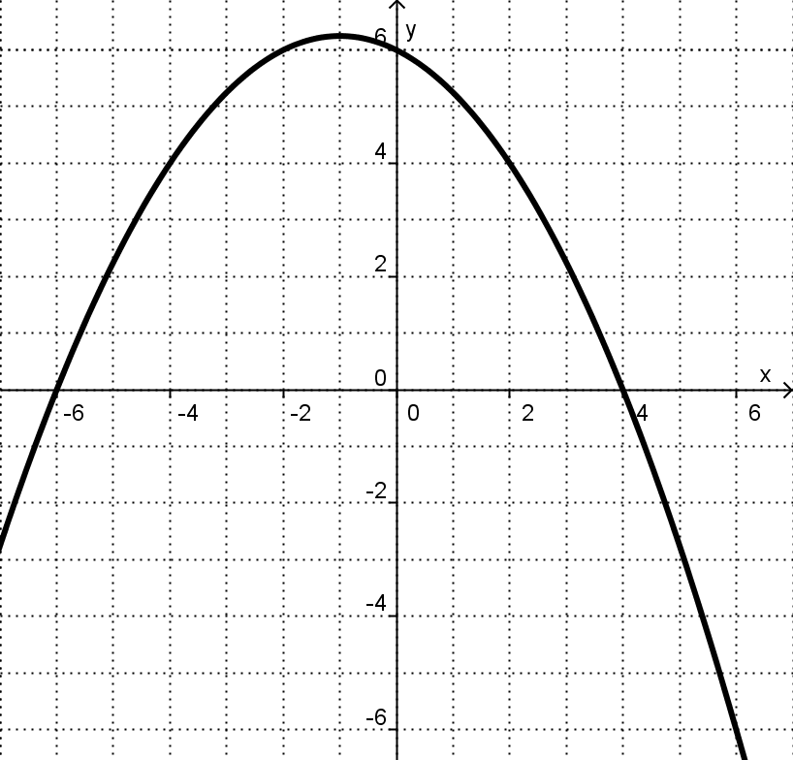
g(x)
x

y = g(x)
p
S(p)
S(p) = number of
siblings of p
t
h(t)

- g(7)

The set of all inputs which a function accepts is called the domain of the function. The set of all outputs resulting from the acceptable inputs is called the range.

22. State the domain and range of each function.

 |  | domain | range

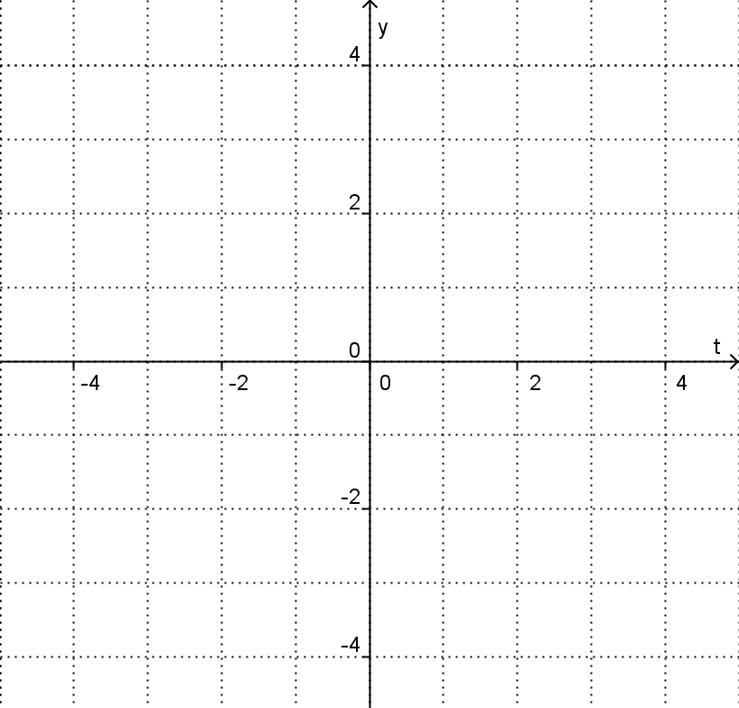
23. Carefully graph
© Laura Kinnel

